参考：<http://www.jb51.net/article/119699.htm>

**linux下多个mysql5.7.19(tar.gz)安装图文教程**

作者：wolf_love666 字体：[[增加](javascript:turnbig()) [减小](javascript:turnsmall())] 类型：转载 时间：2017-07-27[我要评论](http://www.jb51.net/article/119699.htm#comments)

这篇文章主要为大家详细介绍了linux下多个mysql5.7.19tar.gz安装教程，具有一定的参考价值，感兴趣的小伙伴们可以参考一下

初级第一次在[Linux下安装MySQL-5.7.19版本教程](http://www.jb51.net/article/119690.htm)请看上一篇，如果已经会安装了，那么请看这篇linux下安装多个mysql-5.7.19

环境：centos 6.5

1-下载

[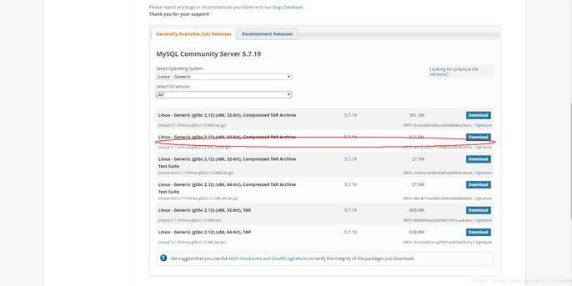](http://files.jb51.net/file_images/article/201707/201772795318455.jpg?201762795353)

2-跳过登陆

[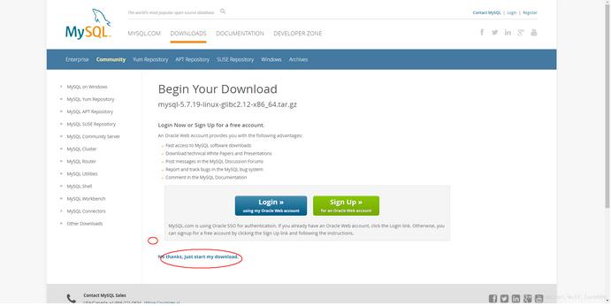](http://files.jb51.net/file_images/article/201707/201772795359941.jpg?20176279548)

3-1安装多个数据库需要配置自己的my.cnf，如果只安装一个，系统没有安装过直接这个命令就可以

[?](http://www.jb51.net/article/119699.htm)

|  |  |
| --- | --- |
| 1  2  3  4  5  6  7  8  9  10  11  12  13  14  15  16  17  18  19 | shell> groupadd mysql  shell> useradd -r -g mysql -s /bin/false mysql  shell> cd /usr/local  shell> tar zxvf /path/to/mysql-VERSION-OS.tar.gz  shell> ln -s full-path-to-mysql-VERSION-OS mysql  shell> cd mysql  shell> mkdir mysql-files  查看下有没有data目录如果没有的话增加个命令（mkdir data）  shell> chmod 750 mysql-files  shell> chown -R mysql .  shell> chgrp -R mysql .  shell> bin/mysql_install_db --user=mysql # MySQL 5.7.5  shell> bin/mysqld --initialize --user=mysql # MySQL 5.7.6 and up  shell> bin/mysql_ssl_rsa_setup  # MySQL 5.7.6 and up  shell> chown -R root .  shell> chown -R mysql data mysql-files  shell> bin/mysqld_safe --user=mysql &  # Next command is optional  shell> cp support-files/mysql.server /etc/init.d/mysql.server |

安装好了就可以直接跳到登陆 步骤5

下面说安装多个mysql情况：

3-2安装多个数据库需要安照如下命令：

1-增加配置文件 my.cnf (在mysql目录下命令touch my.cnf)：

下面配置文件可以直接使用粘贴复制进去

然后创建log文件 /xcxyz/log/mysql/error.log

[?](http://www.jb51.net/article/119699.htm)

|  |  |
| --- | --- |
| 1  2  3  4  5  6  7  8  9  10 | [mysqld]  basedir= /usr/local/mysql-5.7.19-3307  datadir = /usr/local/mysql-5.7.19-3307/data  port = 3307  character-set-server=utf8  server_id = 11  #该socket最好指定，不指定的话默认的话 是使用的默认的socket文件 而且登陆数据库的时候会有我下面的问题  socket = /tmp/mysql3307.sock  log-error = /xcxyz/log/mysql/error.log  pid-file = /usr/local/mysql-5.7.19-3307/data/mysql-5.7.19-3307.pid |

2-执行如下命令

2-1增加用户 组 我的用户和组都使用的是mysqlosf这个随意

[?](http://www.jb51.net/article/119699.htm)

|  |  |
| --- | --- |
| 1  2  3  4 | shell> groupadd mysql  shell> useradd -r -g mysql -s /bin/false mysql  shell> cd /usr/local  shell> tar zxvf /path/to/mysql-VERSION-OS.tar.gz |

2-2建立软连接：

[?](http://www.jb51.net/article/119699.htm)

|  |  |
| --- | --- |
| 1  2  3 | shell> ln -s full-path-to-mysql-VERSION-OS mysql  shell> cd mysql  shell> mkdir mysql-files |

查看下有没有data目录如果没有的话增加个命令（mkdir data）

2-3授权当前目录：

[?](http://www.jb51.net/article/119699.htm)

|  |  |
| --- | --- |
| 1  2  3 | shell> chmod 750 mysql-files  shell> chown -R mysqlosf .  shell> chgrp -R mysqlosf . |

2-4编译

bin/mysqld --defaults-file=/usr/local/full-path-to-mysql-VERSION-OS/my.cnf --initialize --user=mysqlosf

查看日志输出：vi /xcxyz/log/mysql/error.log  
2017-07-24T03:13:47.933684Z 0 [Warning] TIMESTAMP with implicit DEFAULT value is deprecated. Please use --explicit_defaults_for_timestamp server option (see documentation for more details).  
2017-07-24T03:13:49.979892Z 0 [Warning] InnoDB: New log files created, LSN=45790  
2017-07-24T03:13:50.262941Z 0 [Warning] InnoDB: Creating foreign key constraint system tables.  
2017-07-24T03:13:50.330756Z 0 [Warning] No existing UUID has been found, so we assume that this is the first time that this server has been started. Generating a new UUID: 1d702294-701e-11e7-98a1-00163e30bbf6.  
2017-07-24T03:13:50.340474Z 0 [Warning] Gtid table is not ready to be used. Table 'mysql.gtid_executed' cannot be opened.  
2017-07-24T03:13:50.344419Z 1 [Note] A temporary password is generated for [root@localhost](mailto:root@localhost): jZpgHhigx5>i(特别重要一会初始化密码)

2-5建立密钥

[?](http://www.jb51.net/article/119699.htm)

|  |  |
| --- | --- |
| 1 | shell> bin/mysql_ssl_rsa_setup --defaults-file=/usr/local/mysql-5.7.19-3307/my.cnf |

[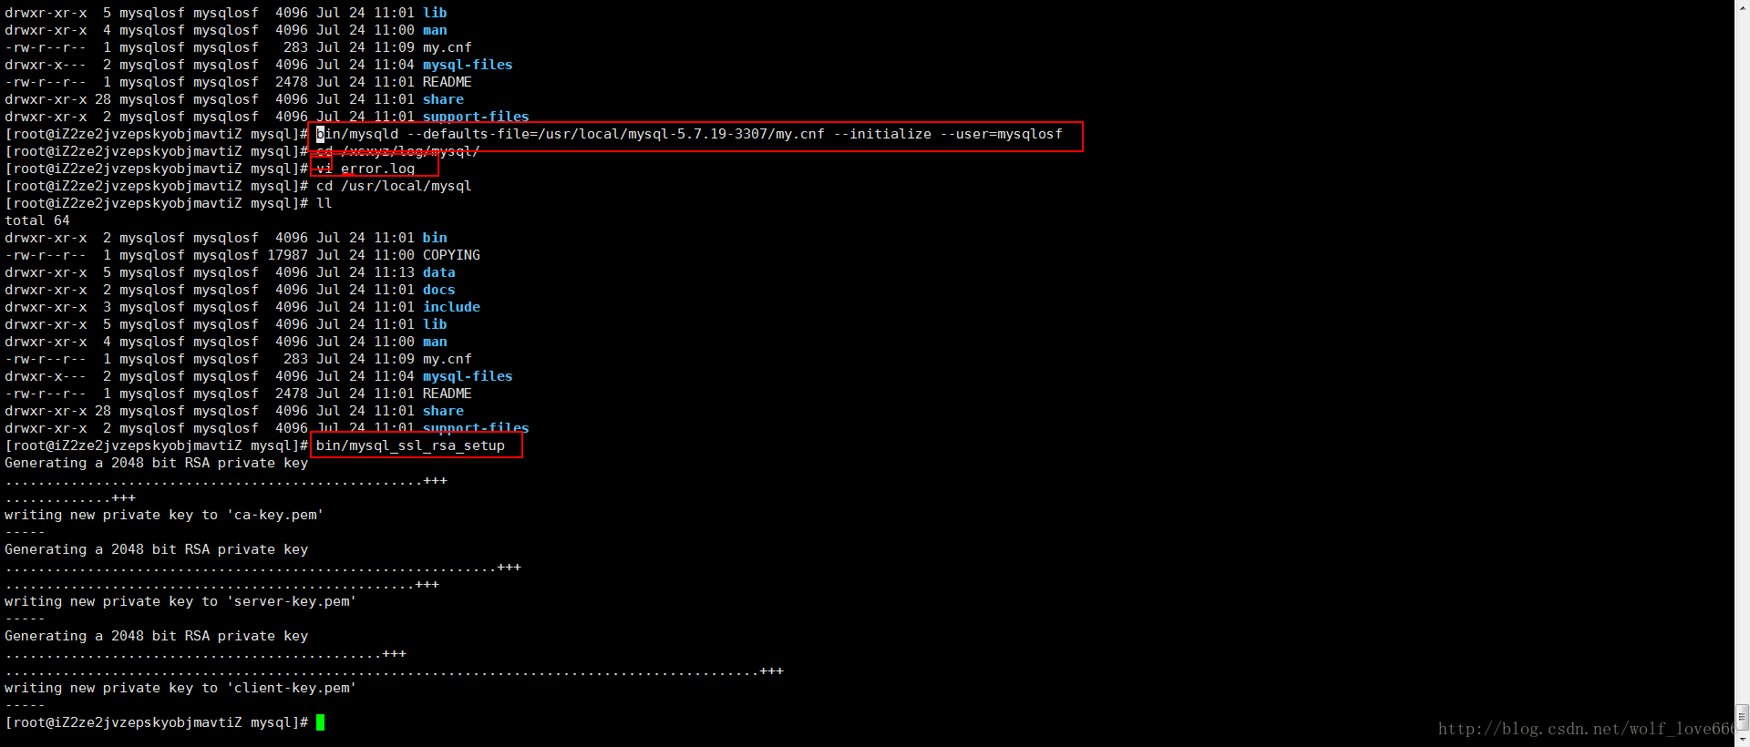](http://files.jb51.net/file_images/article/201707/2017072709375750.png)

2-6重新授权分配

[?](http://www.jb51.net/article/119699.htm)

|  |  |
| --- | --- |
| 1  2 | shell> chown -R root .  shell> chown -R mysql data mysql-files |

2-7启动后台mysql

[?](http://www.jb51.net/article/119699.htm)

|  |  |
| --- | --- |
| 1 | bin/mysqld_safe --defaults-file=/usr/local/full-path-to-mysql-VERSION-OS/my.cnf  --user=mysqlosf & |

[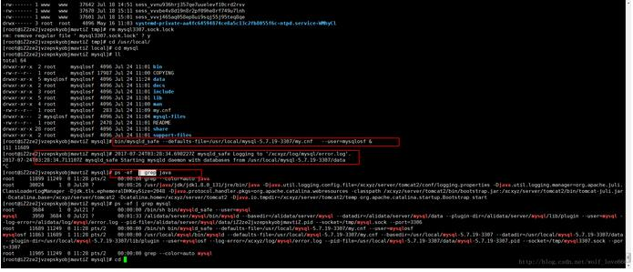](http://files.jb51.net/file_images/article/201707/201772795649666.jpg?201762795659)

**Next command is optional**

[?](http://www.jb51.net/article/119699.htm)

|  |  |
| --- | --- |
| 1 | shell> cp support-files/mysql.server /etc/init.d/mysql.server |

2-8查看mysql是否启动 ps -ef | grep mysql

4登陆mysql修改密码使用刚才的临时密码

[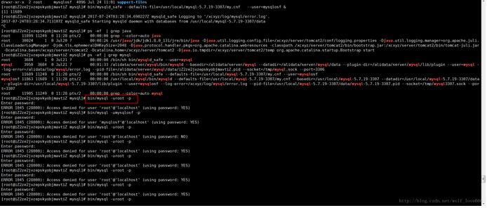](http://files.jb51.net/file_images/article/201707/201772795730252.jpg?201762795746)

我这里又出问题了哈哈，始终登陆不上去

Access denied for user 'root'@'localhost' (using password:YES)解决方法最下面

如果登陆上去了可以直接使用刚才的临时密码登陆并且设置密码

5-登录MySQL之后，要求立即修改密码，否则不能进行任何操作。执行下面的命令修改'root'@'localhost'的密码：

[?](http://www.jb51.net/article/119699.htm)

|  |  |
| --- | --- |
| 1  2  3 | SET PASSWORD = PASSWORD('root');   ALTER USER 'root'@'localhost' PASSWORD EXPIRE NEVER;  flush privileges; |

6-为了可以远程登录，增加一个'root'@'%'账号：

[?](http://www.jb51.net/article/119699.htm)

|  |  |
| --- | --- |
| 1 | grant all privileges on *.* to 'root'@'%' identified by 'root' with grant option; |

7-本地测试连接

按照上面的办法，继续解压安装mysql-5.7.19-linux-glibc2.5-x86_64.tar.gz，并且配置为3308,3309端口，就可以安装多个mysql了。

解决方案安装好了登陆不上去：   
如果像我上面一样的话   
原因是如下红色框内的英文 我的是第二个mysql需要指定socket和port，英文意思就是说 如果你没有指定socket的话那么会选择默认的 因为我们安装多个mysql 所以这个必须指定

[?](http://www.jb51.net/article/119699.htm)

|  |  |
| --- | --- |
| 1 | mysql --socket=/tmp/mysql3307.sock --port=3307 -uroot -p |

[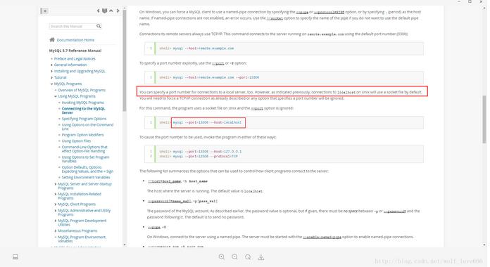](http://files.jb51.net/file_images/article/201707/201772795756254.jpg?20176279585)

如果这里不小心丢失了密码了或者密码过期了那么可以通过这个方式重置密码：

[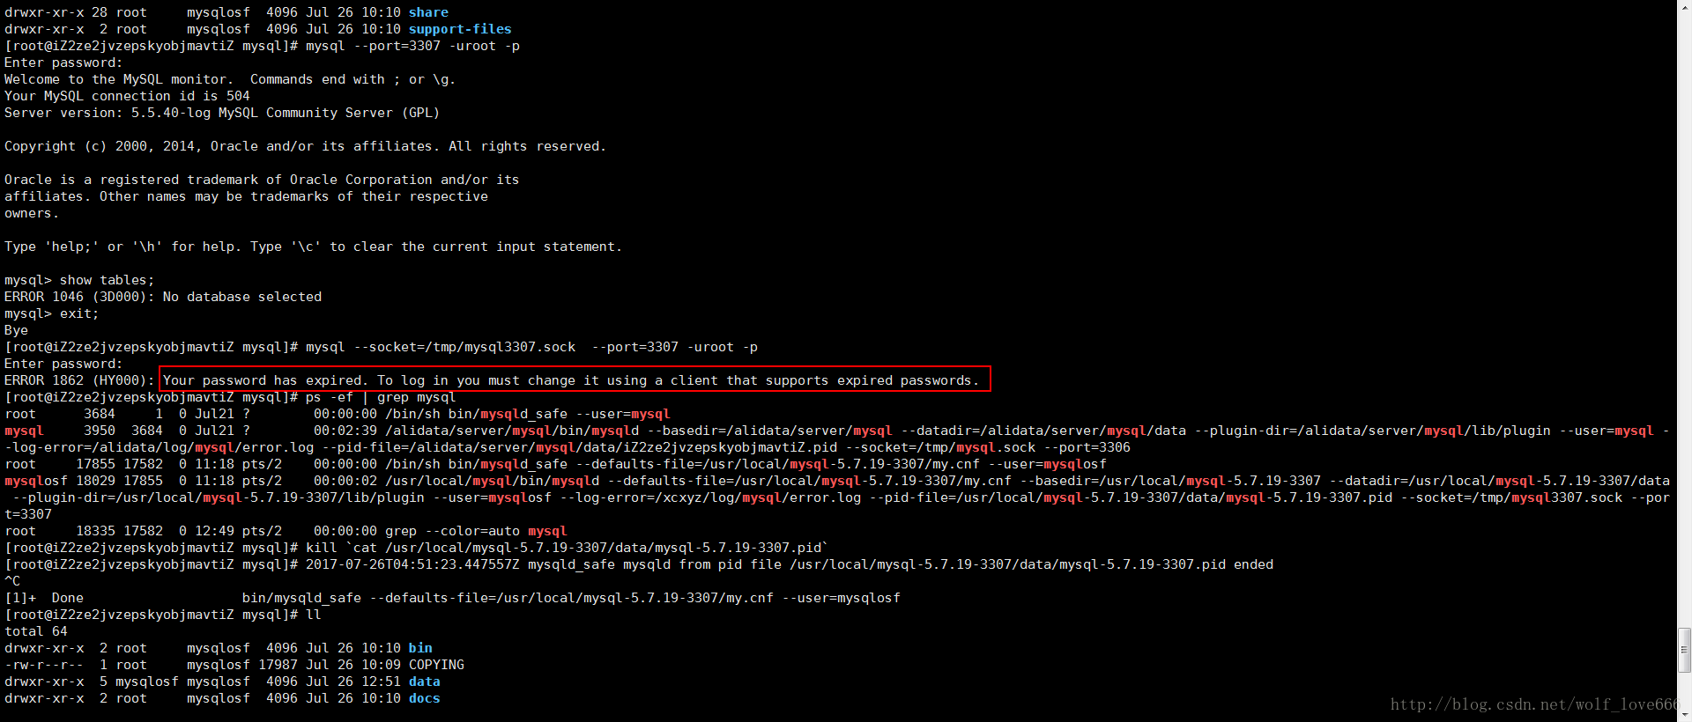](http://files.jb51.net/file_images/article/201707/2017072709375854.png)

5-重置密码：

5-1关闭进程

[?](http://www.jb51.net/article/119699.htm)

|  |  |
| --- | --- |
| 1 | kill `cat /usr/local/mysql-5.7.19-3307/data/mysql-5.7.19-3307.pid` |

5-2创建文件mysql-init

[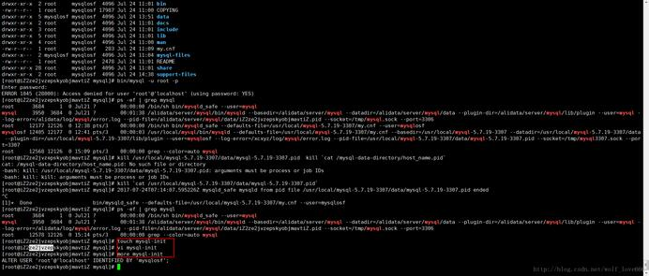](http://files.jb51.net/file_images/article/201707/201772795849725.jpg?201762795859)

5-2-1文件内容

第一种内容：

[?](http://www.jb51.net/article/119699.htm)

|  |  |
| --- | --- |
| 1 | ALTER USER 'root'@'localhost' IDENTIFIED BY 'mysqlosf'; |

[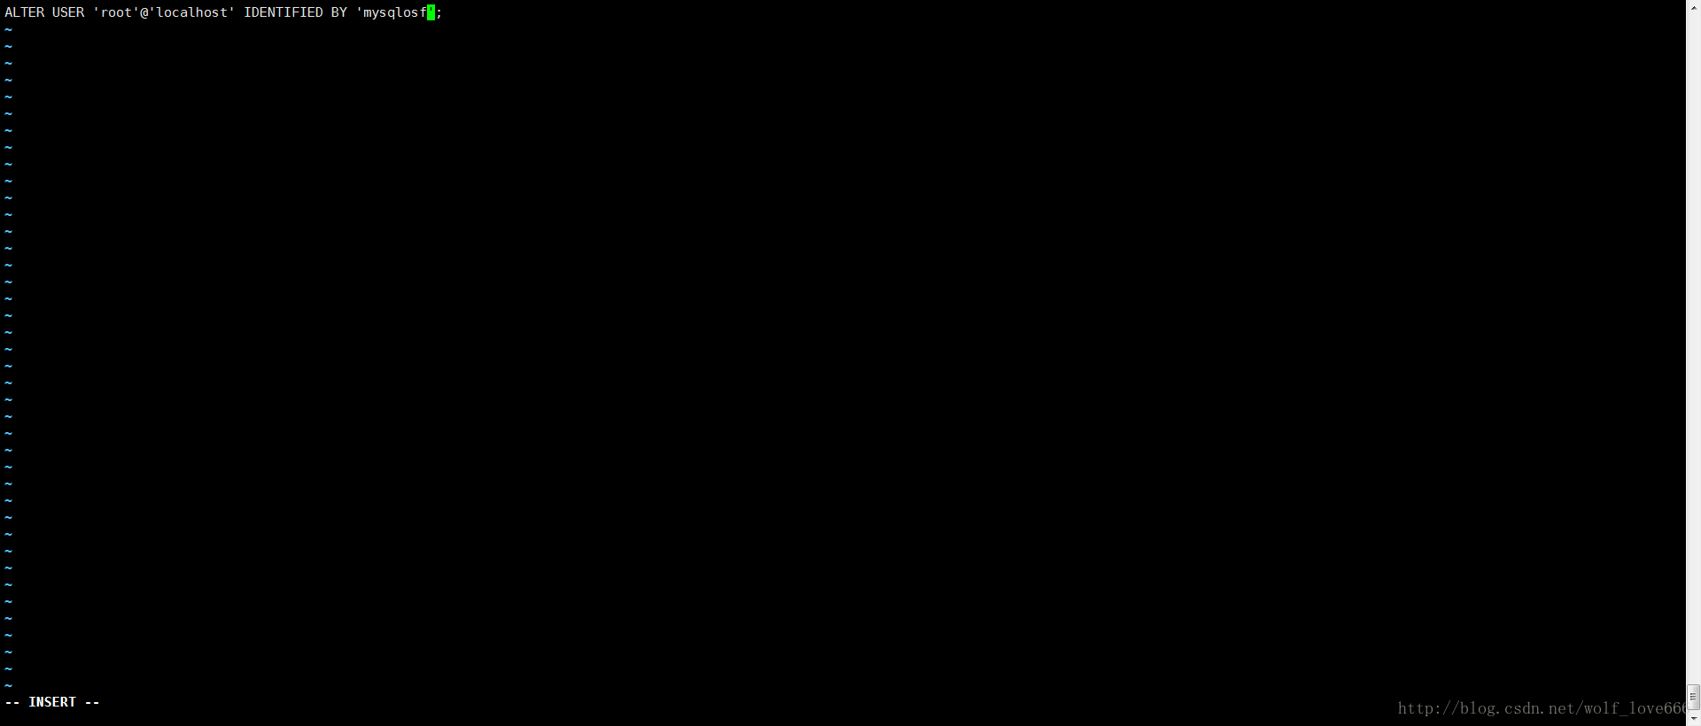](http://files.jb51.net/file_images/article/201707/2017072709375856.png)

保存内容之后启动

复制代码代码如下:

bin/mysqld_safe --defaults-file=/usr/local/mysql-5.7.19-3307/my.cnf  --init-file=/usr/local/mysql-5.7.19-3307/mysql-init    --user=mysqlosf     &

如果上述内容不成功选择第二种内容

[?](http://www.jb51.net/article/119699.htm)

|  |  |
| --- | --- |
| 1  2  3  4 | UPDATE mysql.user   SET authentication_string = PASSWORD('MyNewPass'), password_expired = 'N'   WHERE User = 'root' AND Host = 'localhost';  FLUSH PRIVILEGES; |

[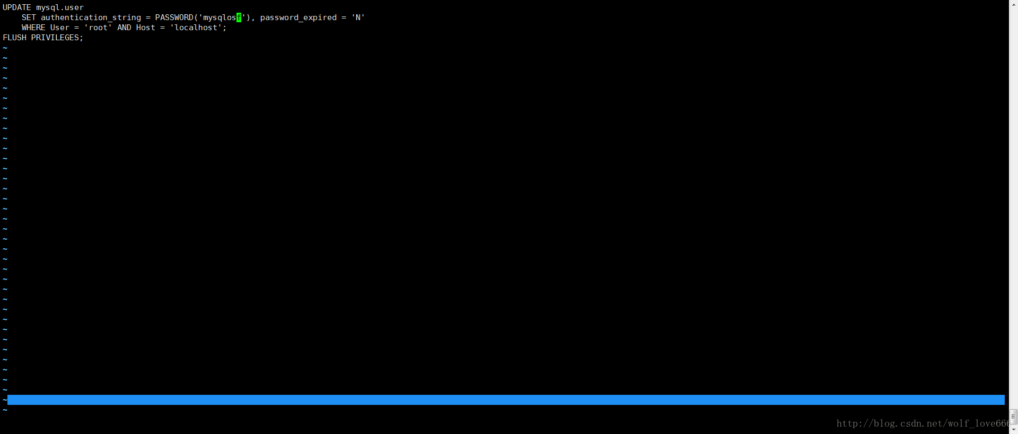](http://files.jb51.net/file_images/article/201707/2017072709375857.png)

保存内容之后启动

复制代码代码如下:

bin/mysqld_safe --defaults-file=/usr/local/mysql-5.7.19-3307/my.cnf  --init-file=/usr/local/mysql-5.7.19-3307/mysql-init   --user=mysqlosf     &

[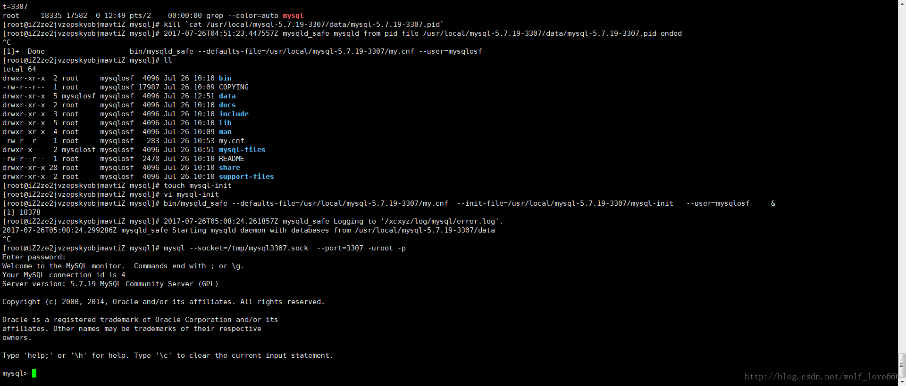](http://files.jb51.net/file_images/article/201707/2017072709375958.png)

以上就是本文的全部内容，希望对大家的学习有所帮助，也希望大家多多支持脚本之家。

s